**Contact:** Jim Rockwell **Embargoed Until January 23, 2025**

RBI Music

**Tel:** 201-247-7224

**Email:** marketing@rbimusic.com

**Toca Bantam Weight Cajon: Lightweight, Responsive, and Powerful**

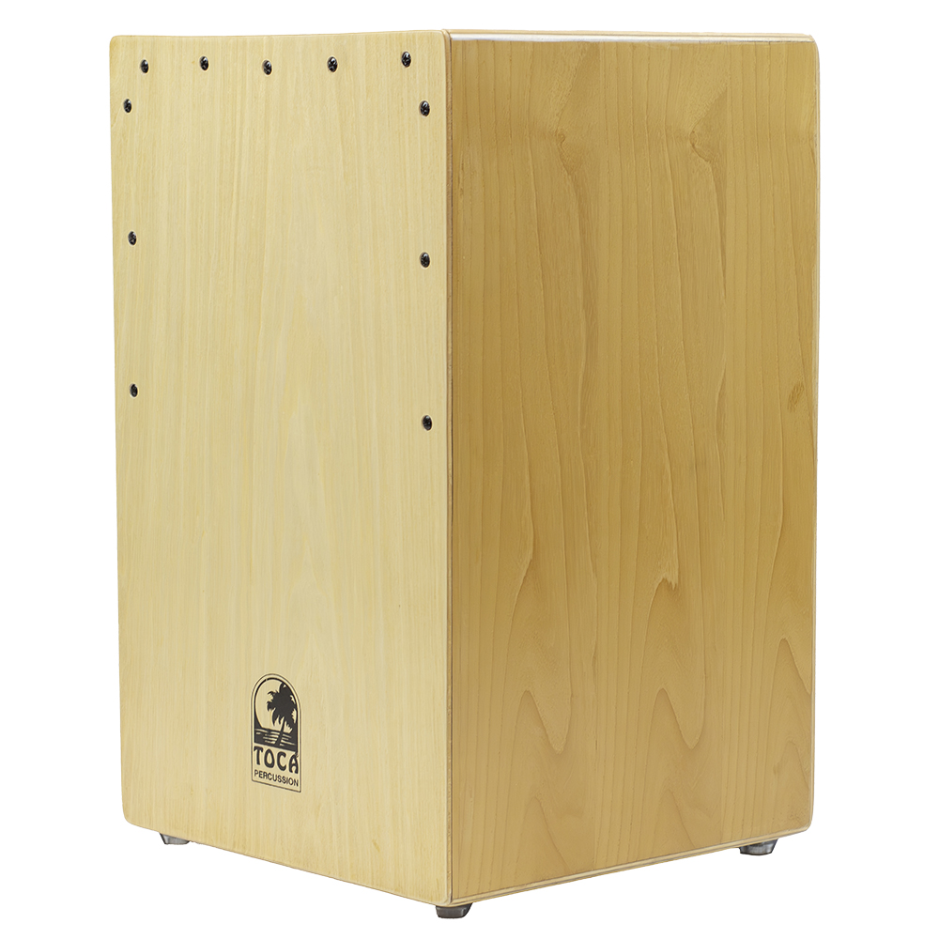Toca Percussion announces the launch of the *Bantam Weight Cajon*, an innovative addition to its cajon lineup that offers musicians a lighter, more responsive instrument without compromising on sound quality.

Designed with a Bali Birch body and a Maple front plate, the Bantam Weight Cajon is nearly three pounds lighter than Toca’s standard cajons, making it easier to carry to gigs, practice sessions, or performances. This reduced weight is achieved without sacrificing the full, rich sound that players expect. The thinner front plate enhances response, allowing for greater precision and sensitivity, while Toca’s bass reflex design extends and enriches bass tones, delivering a robust low end.

Equipped with an internal snare, the Bantam Weight Cajon provides a crisp, snappy sound alongside its deep bass response, making it versatile for a wide range of musical styles. The Bali Birch and Maple construction lends the cajon a simple yet elegant appearance, reflecting its balance of craftsmanship and practicality, adding a touch of class to any stage.

“The Bantam Weight Cajon is a game-changer for musicians who value both portability and performance,” said Jim Rockwell, Toca Product Manager. “We’ve reimagined the traditional cajon to make it lighter and more responsive while maintaining the punch and bass response players love. It’s a beautifully designed instrument that delivers in every way.”

The Bantam Weight Cajon retains the same shape and dimensions as Toca’s standard cajons, ensuring a familiar feel for seasoned players and an intuitive design for newcomers.

tocapercussion.com