**Contact:** Jim Rockwell **Embargoed Until January 23, 2025**

RBI Music

**Tel:** 201-247-7224

**Email:** marketing@rbimusic.com

**Toca Introduces the Anthony Almonte Neptune Signature Series Congas & Bongos**

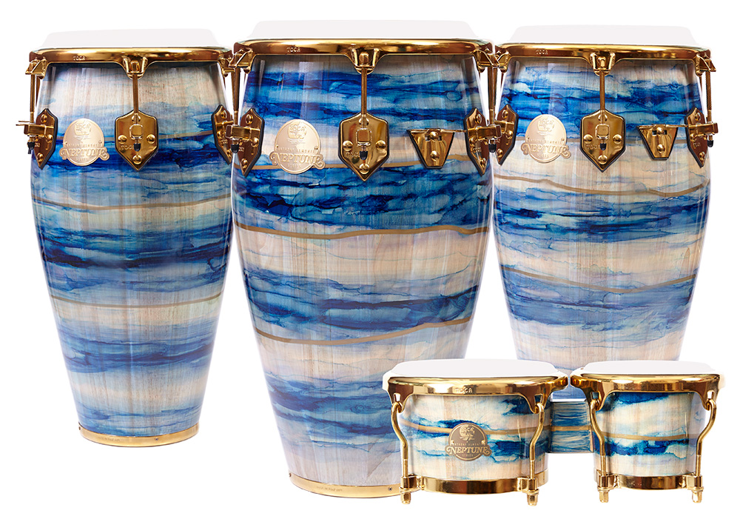Toca Percussion is over the moon to announce the Anthony Almonte Signature Series Congas and Bongos, designed in collaboration with Anthony Almonte, percussionist for Bruce Springsteen and Steven Van Zandt. This collection represents a stunning fusion of artistry and craftsmanship, delivering instruments that are as visually striking as they are musically versatile.

The design, developed by Anthony himself in partnership with Toca’s expert team, introduces a groundbreaking approach to drum finishes. Using a mix of color washes in a spectrum of blues and aquas, the finish is meticulously applied by hand to showcase the natural blonde wood grain beneath. Gold accents trace the drum's circumference, creating a dynamic and elegant aesthetic. This handcrafted process ensures that each drum is a unique masterpiece, making the series a celebration of individuality.

The congas, are crafted from two-ply premium Asian Oak and standing at 30 inches tall, these drums offer a traditional hourglass silhouette. The Remo® synthetic heads, gold EasyPlay hoops, and six tuning lugs provide a harmonious blend of professional-grade sound and easy playability, delivering everything from fat bass tones to sharp, cutting slaps.

The bongos in this series are equally impressive, with 7-inch and 9-inch Remo synthetic heads and the same breathtaking Neptune finish as the congas. Constructed with two-ply Asian Oak and featuring gold hardware, EasyPlay hoops, and eight tuning lugs, they offer stunning aesthetics paired with professional sound quality and durability.

Jim Rockwell, Toca’s Product Manager, spoke about the new series: “Anthony Almonte has brought his talent and vision to some of the greatest musical stages in the world, and we are honored to collaborate with him on this project. The Neptune Signature Series embodies his artistry and passion for percussion, offering musicians instruments that inspire both visually and sonically.”

tocapercussion.com