**Contact:** Jim Rockwell **Embargoed Until January 23, 2025**

RBI Music

**Tel:** 201-247-7224

**Email:** marketing@rbimusic.com

**Toca Commuter Congas Now Available in 12” Model**

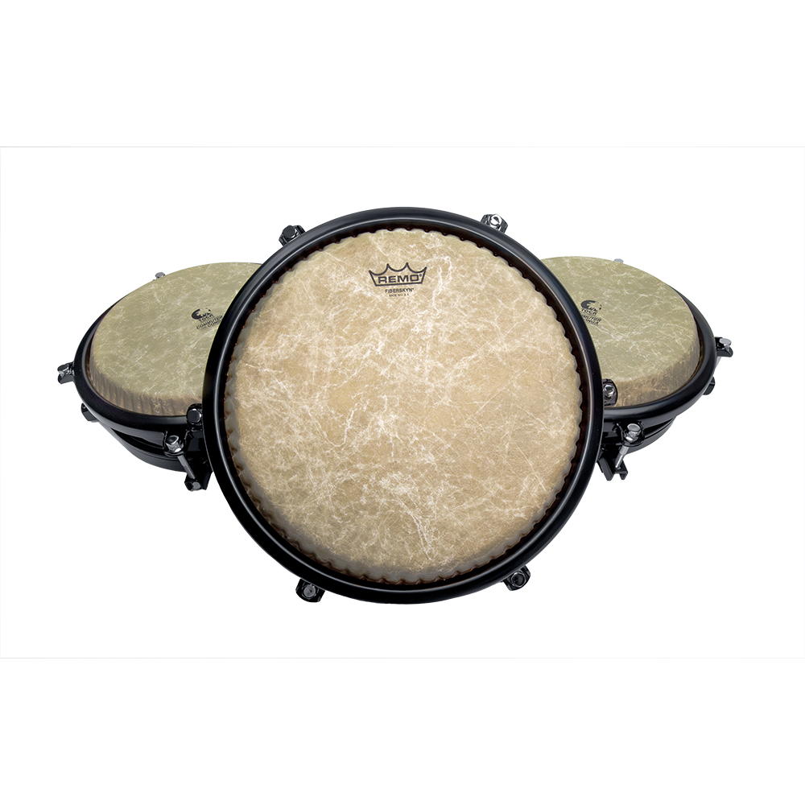

Toca Percussion has announced the expansion of its innovative **Commuter Congas**, now available in a 12” size. Joining the existing 10” and 11” models, the new 12” drum offers even greater versatility and depth, allowing players to achieve a full, traditional conga setup in a compact and portable package.

The Commuter Congas, first released in 2023, have become a favorite among musicians for their lightweight design, compact size, and professional sound. Each drum in the series is fitted with Remo Fiberskyn heads for warm, authentic tones and long-lasting durability. The 10” drum features a 3” diameter port on the bottom, enhancing crisp highs and clear slaps, while the 11” drum has a 6” diameter port that delivers balanced mid-tones and robust bass. The new 12” model also features a 6” diameter port but adds deeper bass and thicker mid-tones, rounding out the tonal palette.

Each drum is designed for easy tuning, with accessible lugs at the top for quick adjustments. Optional heavy-duty steel stands are available, featuring adjustable arms to securely hold any size of Commuter Conga. The introduction of the 12” drum allows players to recreate the classic Quinto, Conga, and Tumba setup, offering a wide range of sounds in a travel-friendly design.

"The addition of the 12” Commuter Conga gives players a complete tonal range in a portable format," said Jim Rockwell, Toca Product Manager. "This new size rounds out the series, enabling drummers to create the traditional conga setup they love, but in a compact, travel-friendly design. It’s a game-changer for musicians who value portability and exceptional sound."

With its expanded size options, the Commuter Conga series offers a versatile solution for gigging musicians, drum circle enthusiasts, and players of all levels. The drums are sold separately, and with or without stands.

tocapercussion.com