**Contact:** Rick Taylor

RBI Music

**Tel:** 817-335-2561 x105

**Email:** [rick.taylor@rbimusic.com](mailto:rick.taylor@rbimusic.com)

**Silvertone® and Rio Grande Pickups Collaborate to Launch New Silvertone Lipstick Pickup**

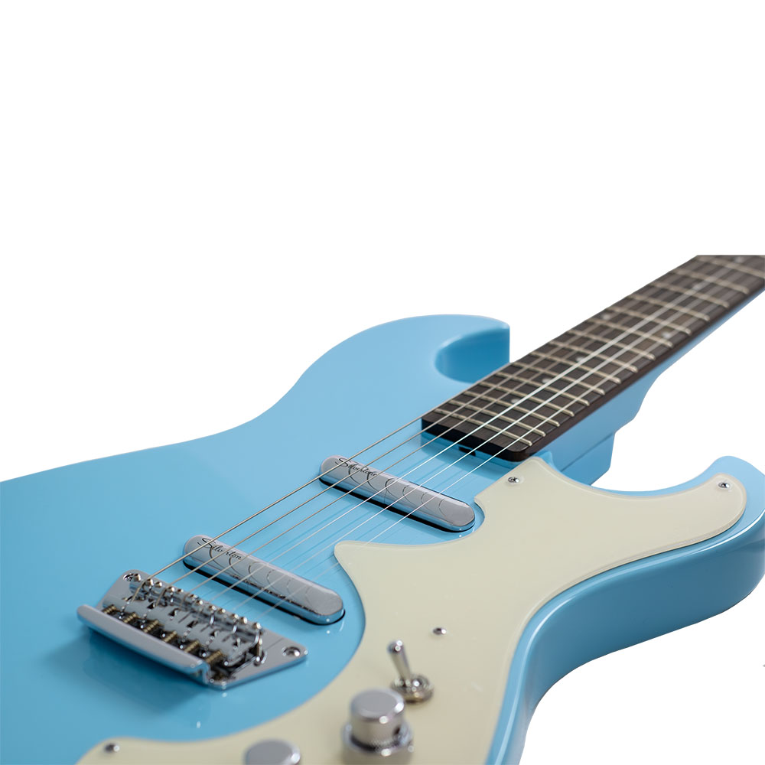Silvertone Guitars is thrilled to announce a groundbreaking collaboration with Rio Grande Pickups to introduce a new Silvertone Lipstick pickup. This partnership combines Silvertone’s iconic legacy with Rio Grande’s expert craftsmanship to create a pickup that delivers a bold, traditional single-coil tone while retaining the classic Lipstick look.

The original Lipstick pickup, invented by Nathan Daniels, is celebrated for its distinctive sound with a bright, trebly top end and scooped midrange, offering a unique sonic character that stands out both in recordings and live performances. While the classic Silvertone Lipstick pickups are known for capturing this vintage tone, the new Silvertone/Rio Grande Lipstick pickups provide an exciting twist for players seeking a higher-output, traditional single-coil sound.

Designed and handmade in Houston, Texas, the new Silvertone Lipstick pickup features an Alnico 5 bar magnet, plain enamel 44AWG pure copper wire, and a shielded 2-wire connection for versatile wiring options. This pickup strikes a perfect balance between a '60s Strat®-style sound and the powerful punch of a P90, offering a beefy midrange and enhanced output for dynamic lead playing and driving effects pedals.

“We’re thrilled to be working with Rio Grande Pickups on this new Lipstick design,” says Rick Taylor, Guitar Product Manager at Silvertone Guitars. “This collaboration has allowed us to expand the tonal palette of our Lipstick pickups while preserving the visual appeal that players love. The new pickups deliver rich, powerful sound that will inspire musicians to explore new creative possibilities.”

*The Silvertone/Rio Grande Lipstick pickups are available in two configurations. The ‘long bracket’ version is designed for current Silvertone models, while the ‘short bracket’ version fits many vintage Silvertone guitars, including the original 1303 and 1449 ‘Amp in Case’ models, making it easier than ever to upgrade your instrument with no modifications needed.*

These new pickups are the perfect way to supercharge your guitar, combining the distinctive look of the Lipstick design with the versatile, high-output tone that modern players demand.

For more information about Silvertone, please visit [**SilvertoneGuitars.com**](https://silvertoneguitars.com/)

Silvertone Guitars is a wholly owned brand of RBimusic.