**Contact:** Rick Taylor

RBI Music

**Tel:** 817-335-2561 x105

**Email:** [rick.taylor@rbimusic.com](mailto:rick.taylor@rbimusic.com)

**Silvertone® Guitars Announces Limited Edition 1449 Model in Silver Sparkle**

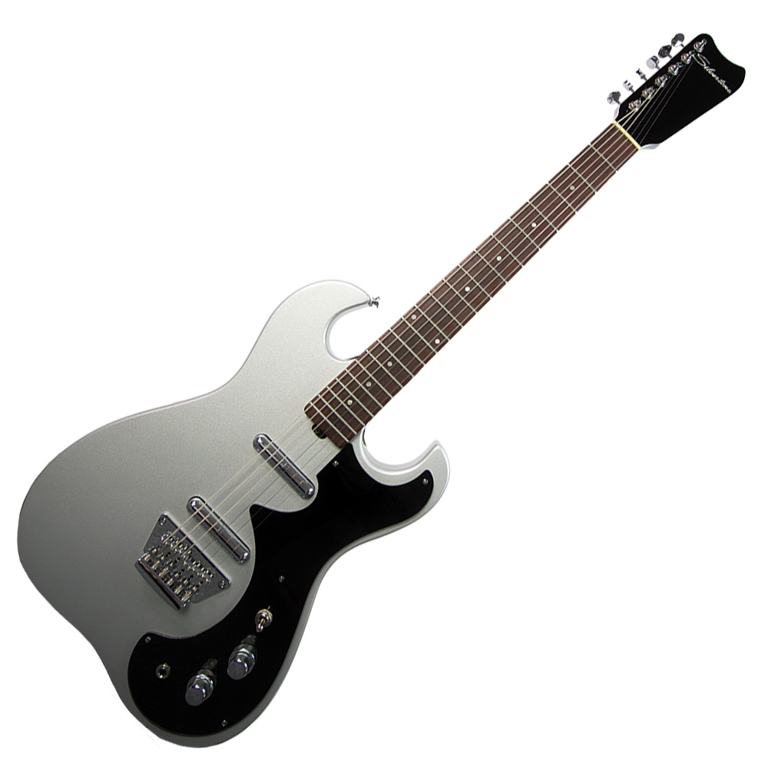Silvertone Guitars is excited to unveil a limited edition, only 30 units available, of the iconic 1449 model in a stunning Silver Sparkle finish. This release brings back the legendary 1449 with the same spirit and style that made it a standout during the early ’60s guitar boom. Known for its unique Amp-in-case feature, this limited edition is a tribute to one of the most innovative concepts in guitar history.

The Amp-in-case line of the early ’60s offered musicians an affordable way to rock out wherever they were. For less than $100, guitarists could get their hands on an instrument that came in a case equipped with a built-in 5-watt (later 6-watt) tube amp. All you had to do was open the case halfway, stand it up, switch it on, and start playing.

The 1449 was produced for only a short period before being replaced by the nearly identical redburst 1457 in 1964, making this reissue a unique opportunity for guitar enthusiasts.

“The Silvertone 1449 is an incredible piece of history, and we’re thrilled to bring it back in such a stunning finish,” says Rick Taylor, Guitar Product Manager at Silvertone Guitars. “The Silver Sparkle edition not only pays homage to the original design but also adds a modern flair that today’s players will love. It’s not just a guitar; it’s a piece of Americana that screams style and sound.”

This limited edition 1449 Silver Sparkle model is available now. For more information please visit <https://silvertoneguitars.com/collections/1449/products/1449-ss>

For more information about Silvertone, please visit [**SilvertoneGuitars.com**](https://silvertoneguitars.com/)

Silvertone Guitars is a wholly owned brand of RBimusic.