**Contact:** Jim Rockwell **EMBARGOED UNTIL JAN 23, 2025**

RBI Music

**Tel:** 201-247-7225

**Email:** marketing@rbimusic.com

**RBI to Distribute the Redesigned P4 Practice Pad by Pat Petrillo**

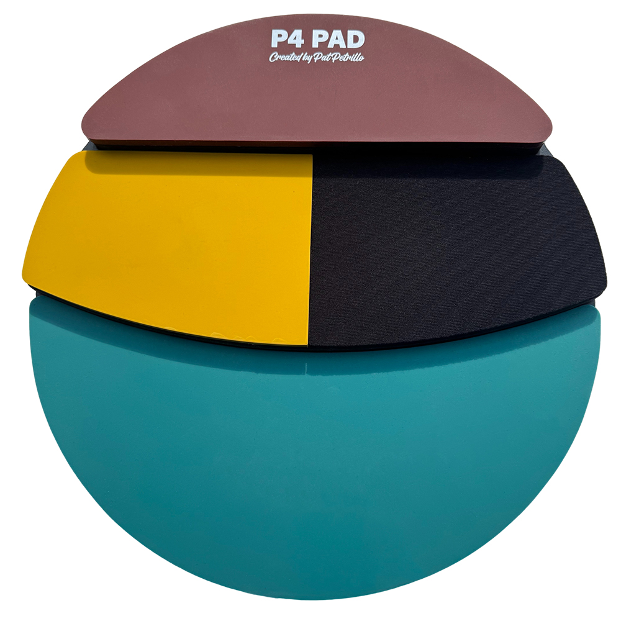RBI Music is thrilled to announce its upcoming distribution in North and South America of the original P4 Practice Pad, designed by world-renowned drummer and educator Pat Petrillo. The updated P4 Practice Pad boasts bright new colors and enhanced, more durable practice surfaces for an improved playing experience.

The P4 Practice Pad is a one-of-a-kind multi-level pad, offering four distinct playing surfaces, each with unique rebound responses. Designed to replicate the feel of an entire drum set, it makes practicing more dynamic, musical, and engaging. The main silicone surface provides a natural snare drum-like response. The middle level includes two pads: one with a harder rubber surface that mimics the feel of a rack tom, and another with a soft, quiet rubber surface similar to a floor tom. The top layer features a harder silicone surface that emulates the feel of playing on a ride cymbal or hi-hat. These features work together to enhance rhythmic coordination and make practice sessions more realistic and enjoyable.

“I designed the P4 Practice Pad many years ago to meet my students’ need for something more versatile and engaging than the same old one-surface pad,” said Petrillo. “I’m absolutely thrilled to partner with RBI Music on this new version to make the P4 Pad more accessible than ever. RBI’s passion for supporting drummers aligns perfectly with my vision. Once you try practicing on the P4 Pad, you’ll never look back at a single-surface pad again!”

To help drummers maximize their P4 Pad experience, every purchase includes a QR code for 4 FREE online video lessons (a $200 value) filmed exclusively by Pat Petrillo. These lessons provide expert guidance on utilizing the P4 Pad’s unique features.

[rbimusic.com](https://rbimusic.com/)