**Contact:** Jim Rockwell **FOR IMMEDIATE RELEASE**

**RBI Music**

**Tel:** 201-247-7224

**Email:** jim.rockwell@rbimusic.com

**Grover Pro Founder Neil Grover Inducted Into PAS Hall of Fame**

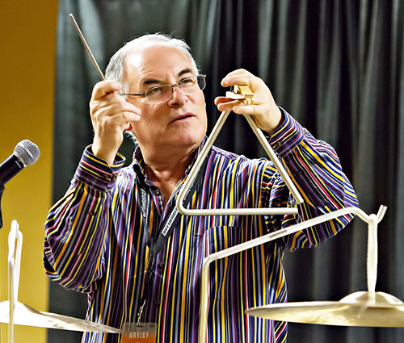The Percussive Arts Society (PAS), a distinguished collective of percussion enthusiasts, has recently announced Neil Grover’s induction into the prestigious PAS Hall of Fame. This milestone event honors Grover’s remarkable talent and his enduring commitment to the world of percussion, reflecting a stellar career that spans over four decades.

Neil Grover is celebrated as a distinguished performer, music educator, instrument innovator, and business pioneer, whose significant influence has resonated throughout the music industry. His illustrious career spans more than 40 years of affiliation with Boston’s top musical organizations, including the acclaimed Boston Symphony and Boston Pops. His educational contributions are marked by his tenure at two prominent university music programs and his authorship of four seminal books on percussion technique.

Grover’s artistic reach extends beyond classical music, most notably having contributed to the iconic scores of Phillip Glass’ “Mishima” and John Williams’ “Indiana Jones and the Temple of Doom,” not to mention performing alongside the legendary rock group Aerosmith.

In harmony with his artistic endeavors, Grover’s entrepreneurial drive and uncompromising passion for percussion led to the founding of Grover Pro Percussion, a company celebrated worldwide for its innovation in crafting superior musical instruments and accessories. His key leadership positions within the Percussive Arts Society, including his tenure on the Board of Directors, the Advisory Board, and his role as Chair of the Symphonic Committee, have been instrumental in ensuring the organization’s continued success.

The forthcoming induction ceremony, scheduled for the Percussive Arts Society International Convention this November, promises to be a festive tribute to Grover’s extraordinary impact on the percussion community worldwide.

groverpro.com

rbimusic.com