**Contact:** Jim Rockwell **For Immediate Release**

**RBI Music**

**Tel:** 201-247-7224

**Email:** jim.rockwell@rbimusic.com

**Grover Pro Percussion Celebrates 45 Years of Craftsmanship and Innovation**

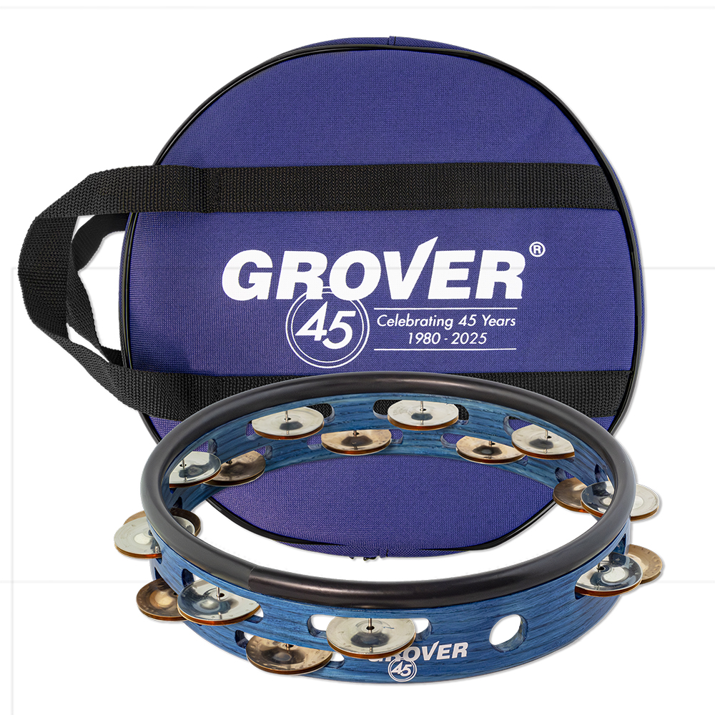Grover Pro Percussion proudly marks its 45th anniversary in 2025, celebrating decades of creating some of the finest percussion instruments in the world. Since its founding in 1980 by Boston-based percussionist Neil Grover, the company’s instruments have become staples for top percussionists, students, and ensembles in virtually every corner of the globe.

The Grover Pro story began with Neil Grover’s quest to reproduce the vibrant sound of a vintage Leedy triangle used by the Boston Symphony. Collaborating with students at MIT’s Acoustics & Vibrations Lab, Neil meticulously analyzed the triangle’s overtone resonance, eventually crafting a 9” triangle for his personal use. The instrument’s exceptional musicality quickly gained attention, and Neil began making triangles by hand for his Boston colleagues, inadvertently launching the now-iconic Grover® Super-Overtone™ triangle.

Over the years, Grover Pro expanded its offerings to include tambourines, mallets, woodblocks, snare drums, and more, always maintaining a commitment to impeccable craftsmanship and superior sound quality. Each product has been personally developed and tested by Neil Grover, ensuring that the company’s high standards of quality remain unmatched.

To commemorate its 45th anniversary, Grover Pro is releasing a limited edition headless tambourine inspired by its renowned Studio Pro model. This celebratory tambourine features a striking sapphire shell and a unique mix of silver, bronze, and copper jingles, accompanied by a matching sapphire 45th-anniversary bag. As a special thank-you, Grover Pro will include this exclusive bag with every professional model tambourine sold throughout 2025.

Neil Grover, Founder of Grover Pro Percussion, reflected on this milestone: “It’s incredible to think that what started as a single triangle has grown into a global brand synonymous with quality and innovation. As we celebrate 45 years, we remain committed to crafting instruments that inspire musicians and enrich performances worldwide.”

groverpro.com