**Contact:** Jim Rockwell **EMBARGOED UNTIL JANUARY 23, 2025**

**RBI Music**

**Tel:** 201-247-7224

**Email:** jim.rockwell@rbimusic.com

**Grover Pro Percussion Re-Introduces the Innovative BlocKnock™**

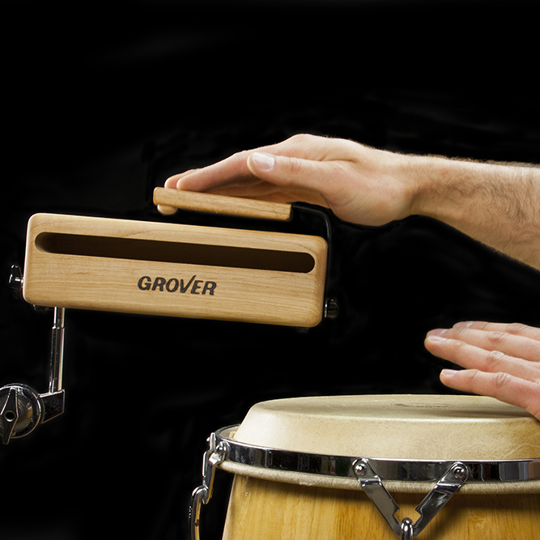Grover Pro, is proud to announce the relaunch of the BlocKnock™, an innovative accessory designed to expand the versatility and playability of wood blocks. Originally introduced in 2014, the BlocKnock™ is now back and ready to provide percussionists with an indispensable tool for modern performance demands.

The BlocKnock™ allows musicians to produce the traditional woody “crack” of a wood block using either a hand or mallet, offering unparalleled flexibility for players across a wide range of musical contexts. This tool is a game-changer for percussionists required to switch instruments rapidly, as well as for show players in pit orchestras and hand drummers looking for enhanced sound options.

Designed for quick and easy use, the BlocKnock™ attaches securely to any Grover Pro wood block and can be removed effortlessly when not in use. Crafted with care from durable coated spring steel and hardwood, it features a specialized striking face to ensure consistent, high-quality sound production across all wood block sizes.

Neil Grover, Founder of Grover Pro Percussion, highlighted the product's return and enduring value: “When we first introduced the BlocKnock™ in 2014, it was met with tremendous enthusiasm from the percussion community. We’re thrilled to bring it back, as it offers musicians a unique combination of efficiency and creativity while delivering the rich, authentic sound Grover Pro is known for.”

groverpro.com

rbimusic.com