**Contact:** Jim Rockwell **FOR IMMEDIATE RELEASE**

RBI Music

**Tel:** 201-247-7224

**Email:** jim.rockwell@rbimusic.com

**Toca Universal Stand Brace: A Revolutionary Solution for Conga Stand Stability**

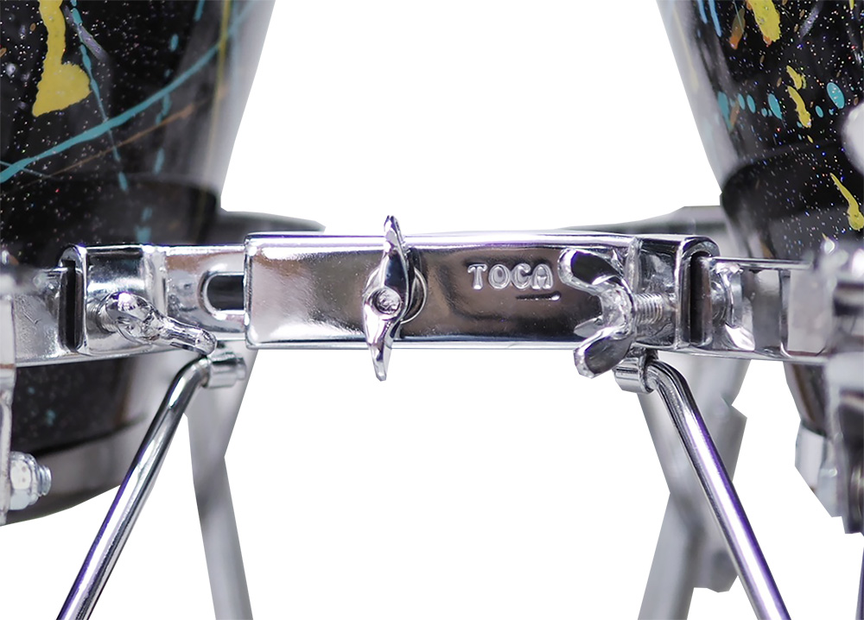Toca Percussion proudly unveils the Toca Universal Stand Brace, a groundbreaking accessory designed to put an end to the frustration of conga stands moving or "walking" during play.

Playing congas can be a truly immersive experience, but the constant need to readjust stands can be terribly frustrating for musicians. The Toca Universal Stand Brace addresses this issue head-on, providing a simple yet effective solution to ensure conga stands stay firmly in place.

The Universal Stand Brace puts an end to the common problem of conga stands shifting during play, allowing musicians to focus on their performance without interruptions. By attaching barrel stands together and utilizing the weight of the stands and connected drums, the Universal Stand Brace provides a stable and secure foundation for congas.

Crafted from chrome-plated steel, the Universal Stand Brace ensures durability and longevity, withstanding the rigors of regular use. The user-friendly design allows for quick and hassle-free installation and removal, taking approximately a minute to set up. This means more time playing and less time adjusting. Each brace supports two congas, making it an ideal solution for various conga setups. For musicians with three congas, two braces can be used to ensure stability.

“The Toca Universal Stand Brace is a great tool for conga players. It not only eliminates the annoying 'walking' issue but also enhances the overall playing experience,” says Toca Marketing and Product Manager, Jim Rockwell. “With this innovative solution, we're empowering musicians to focus on their music, knowing their conga stands will stay right where they should be."

tocapercussion.com

rbimusic.com

l