**Contact:** Jim Rockwell **FOR IMMEDIATE RELEASE**

RBI Music

**Tel:** 201-247-7224

**Email:** jim.rockwell@rbimusic.com

**Toca Percussion Unveils Updated, More Verbose Talking Drum**

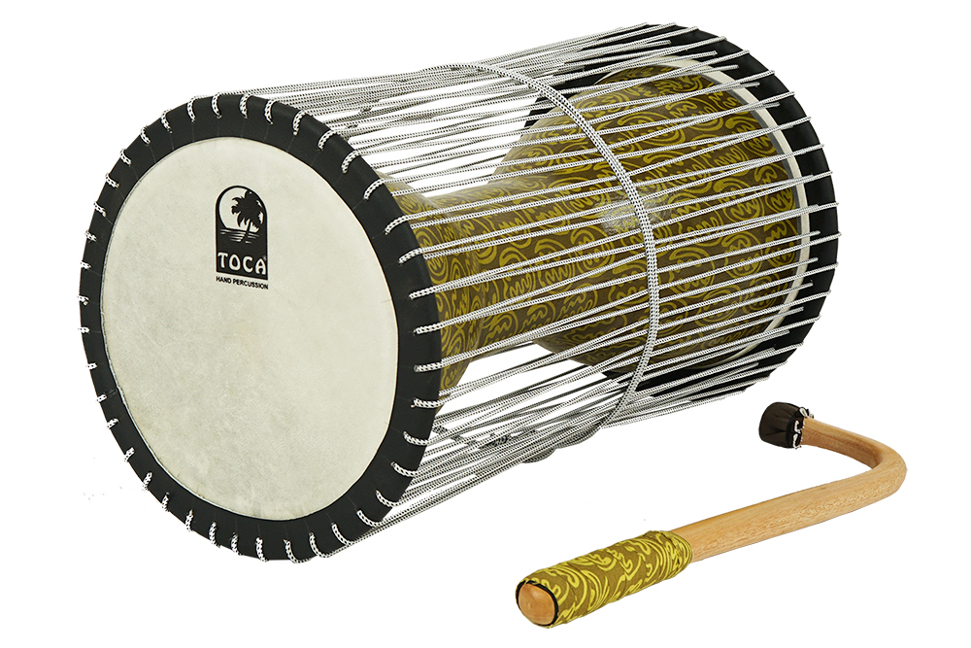The traditional talking drum, known for its hourglass shape, has been a cultural symbol in West Africa for generations. Toca Percussion has meticulously updated their own version of this instrument to meet the demands of contemporary musicians.

The Toca Talking Drum retains the essence of the traditional design, featuring two drumheads connected by tension cords. These cords, when squeezed between the player's arm and body, allow for the regulation of pitch, mimicking the tone of human speech. A skilled player can articulate whole phrases, creating a unique sonic language that echoes the richness of human expression.

Developed in collaboration with Jamal Mohamed, a master of percussion, the new Toca Talking Drum boasts an extremely lightweight and durable synthetic shell. Authentic goatskin heads contribute to the instrument's authentic sound, capturing the spirit of the traditional talking drum.

The drum's striking appearance is enhanced with Toca's iconic African Mask design. The 7-inch heads and 16-inch tall drum shell provide a balanced and versatile canvas for musicians to explore the instrument's sonic possibilities.

One of the standout features of the updated talking drum is the new tension cord system. This system offers a significantly broader range of sounds and tones, allowing musicians to push the boundaries of their creativity. The included beater, reminiscent of traditional beaters, comes with a handle wrap that matches the design on the drum shell, providing both functionality and aesthetic appeal.

tocapercussion.com

rbimusic.com