**Contact:** Jim Rockwell **FOR IMMEDIATE RELEASE**

RBI Music

**Tel:** 201-247-7224

**Email:** jim.rockwell@rbimusic.com

**Toca Sympatico™ Series Accessory Jingles: Expanding Sonic Possibilities**

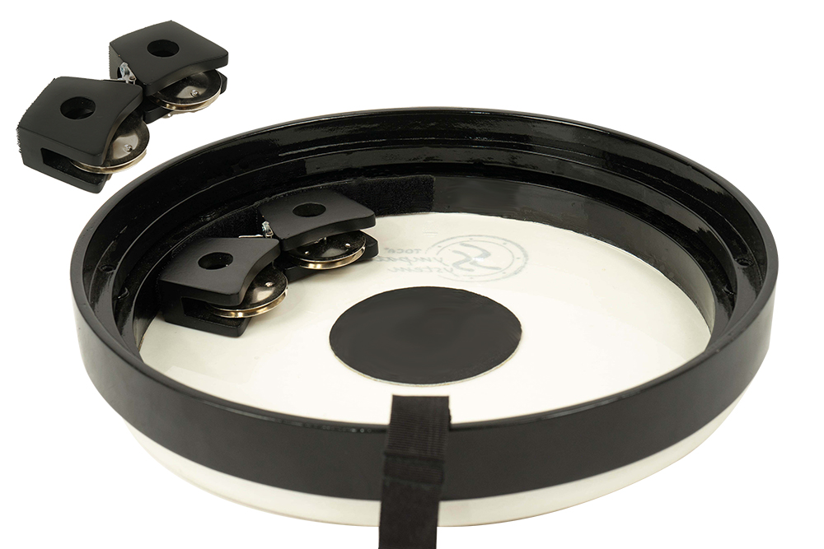Toca Percussion announces the release of the Toca Sympatico Series Accessory Jingles - a groundbreaking addition to the already revolutionary Sympatico System Drums and Heads. As a response to the resounding success of the Sympatico System, these easily attachable accessories further enhance the sound possibilities for drummers in both recreational and educational settings.

The Sympatico System has gained acclaim for its innovative and proprietary internal tuning design. The tuning mechanism is hidden inside the drum, providing a unique and customizable sound that resonates with drummers of all levels.

The Sympatico System, consisting of Nesting Djembes, Nesting Tom-Toms, Nesting Djun-Djuns, Stacking Ashikos, Gathering Drums, and Tubadoras, now welcomes a new accessory sound, jingles, offering a vast array of sonic possibilities. Drummers can use the jingle accessory with the head on the drum or detach it to use as a frame drum, providing even more creative flexibility.

Jim Rockwell, Marketing and Product Manager for Toca Percussion, expressed his enthusiasm stating, "This expansion of the Sympatico System opens up an incredible range of sound variations. The easily attachable jingles, with their hook and loop mechanism, empowers drummers to explore new sonic territories effortlessly."

tocapercussion.com

rbimusic.com