**Contact:** Jim Rockwell **FOR IMMEDIATE RELEASE**

RBI Music

**Tel:** 201-247-7224

**Email:** jim.rockwell@rbimusic.com

**Toca Jamal Signature Doumbek: A Groundbreaking Addition to the Sympatico™ System Line**

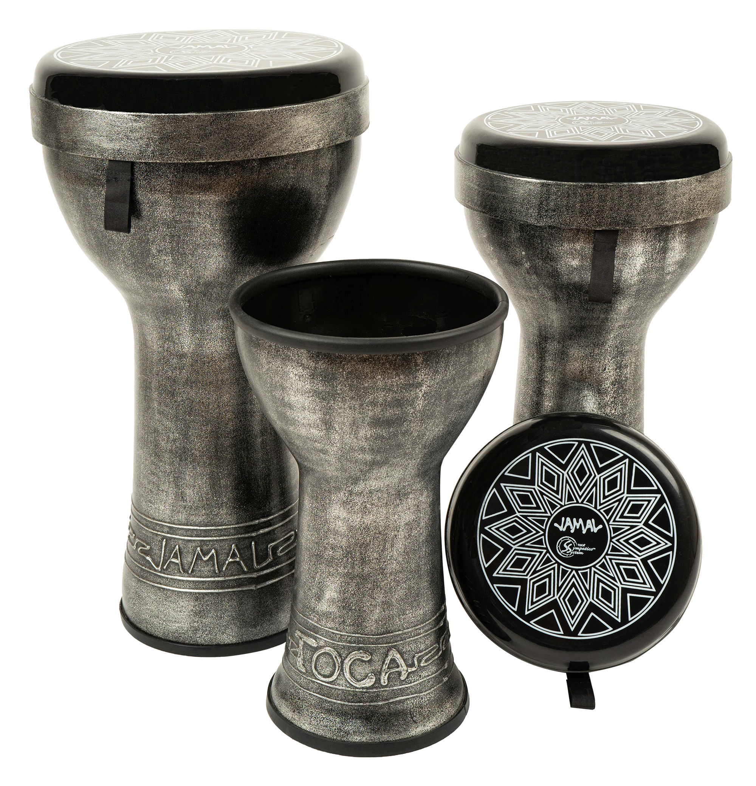Toca Percussion, proudly announces the release of the Toca Sympatico Jamal Signature Doumbek, the latest drum addition to their revolutionary Sympatico System. The system comprises tunable, interchangeable, and lightweight drums and heads, offering a unique musical experience for percussionists worldwide.

Designed in collaboration with the renowned Doumbek Master Jamal Mohamed, the Jamal Signature Doumbeks represent a fusion of traditional craftsmanship and cutting-edge innovation. Jamal stated, "Working on the Sympatico Jamal Signature Doumbek has been a truly inspiring experience. This drum brings a new level of versatility and expression to the world of Doumbeks."

The Sympatico™ System, which already includes Djembes, Ashikos, Djun-Djuns, Tom-Toms, Gathering Drums, and Tubadoras, now welcomes the Jamal Signature Doumbek into its diverse family of percussion instruments. The unique feature of this Doumbek lies in its tunable and replaceable heads, providing players with the ability to customize their sound. Moreover, in keeping with the Sympatico™ System's design ethos, the heads can be detached and played separately as frame drums.

The innovative design of the Jamal Signature Doumbek allows for a rich spectrum of tones, from deep Doums to high Teks, offering a dynamic range for percussionists seeking expressive possibilities in their performance. The drum's shell is not only extremely durable but also meticulously balanced for optimal playability.

To ensure stability during performances, the Jamal Signature Doumbek comes equipped with a protective rubber bottom. The aesthetic appeal of the drum is heightened by its Antique Silver finish, complemented by hand-applied artwork and a custom silk screen, reflecting the artistic craftsmanship synonymous with Jamal Mohamed's signature style.

tocapercussion.com

rbimusic.com