**Contact:** Jim Rockwell **FOR IMMEDIATE RELEASE**

RBI Music

**Tel:** 201-247-7224

**Email:** jim.rockwell@rbimusic.com

**Toca Shell Protectors and Threaded Lug Tips: A New Level of Instrument Protection**

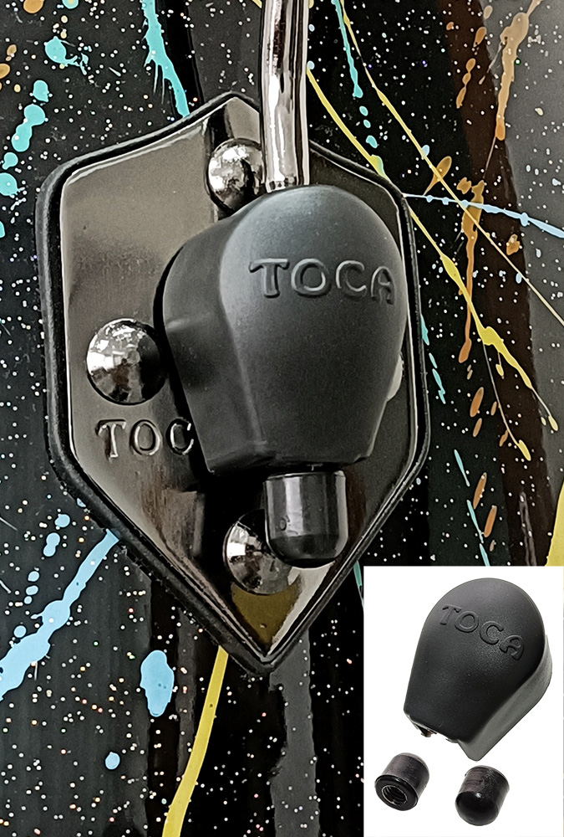Toca Percussion announces the launch of two protective products: Toca Shell Protectors and Toca Threaded Lug Tips. Designed with the utmost care for the preservation of instruments and surrounding surfaces, these accessories redefine the standard of protection for congas and bongos.

In the world of percussion, protection is paramount—for your beloved instruments, your fellow bandmates' gear, and the surfaces that serve as the stage for your performances. Toca's Shell Protectors and Threaded Lug Tips are engineered to safeguard against potential damage, ensuring the longevity of your instruments and the preservation of your performance environment.

The Shell Protectors serve as a shield, preventing collisions that could lead to scratches, dents, or damage to the surface. Whether in the midst of an energetic performance or while transporting your instruments, these protectors offer a robust defense against unwanted wear and tear.

The Threaded Lug Tips take protection to the next level by securely screwing onto the lugs of your congas and bongos. Unlike typical plastic lug tips that are pressed on and prone to falling off, Toca's Threaded Lug Tips remain firmly in place until intentionally removed. This design ensures that your instruments stay protected during play and transport, preventing scratches on drums and surrounding surfaces.

“Our Shell Protectors and Threaded Lug Tips are a game-changer for percussionists seeking reliable and durable protection for their instruments. We've engineered these accessories to address common issues faced by drummers and to provide a worry-free playing experience," says Jim Rockwell, Marketing and Product Manager for Toca Percussion.

Both the Shell Protectors and Threaded Lug Tips come standard on Custom Deluxe and Signature Series congas, and the Threaded Lug Tips come standard on Custom Deluxe and Signature Series and bongos, reflecting Toca's commitment to delivering top-tier protection with their premium instrument lines. For those looking to enhance the protection of their existing drums, these accessories are also available for separate purchase.

tocapercussion.com

rbimusic.com