**Contact:** Jim Rockwell **FOR IMMEDIATE RELEASE**

RBI Music

**Tel:** 201-247-7224

**Email:** jim.rockwell@rbimusic.com

**Toca Releases New Cabasa/Shaker Combo – A Blend of Rhythm and Versatility**

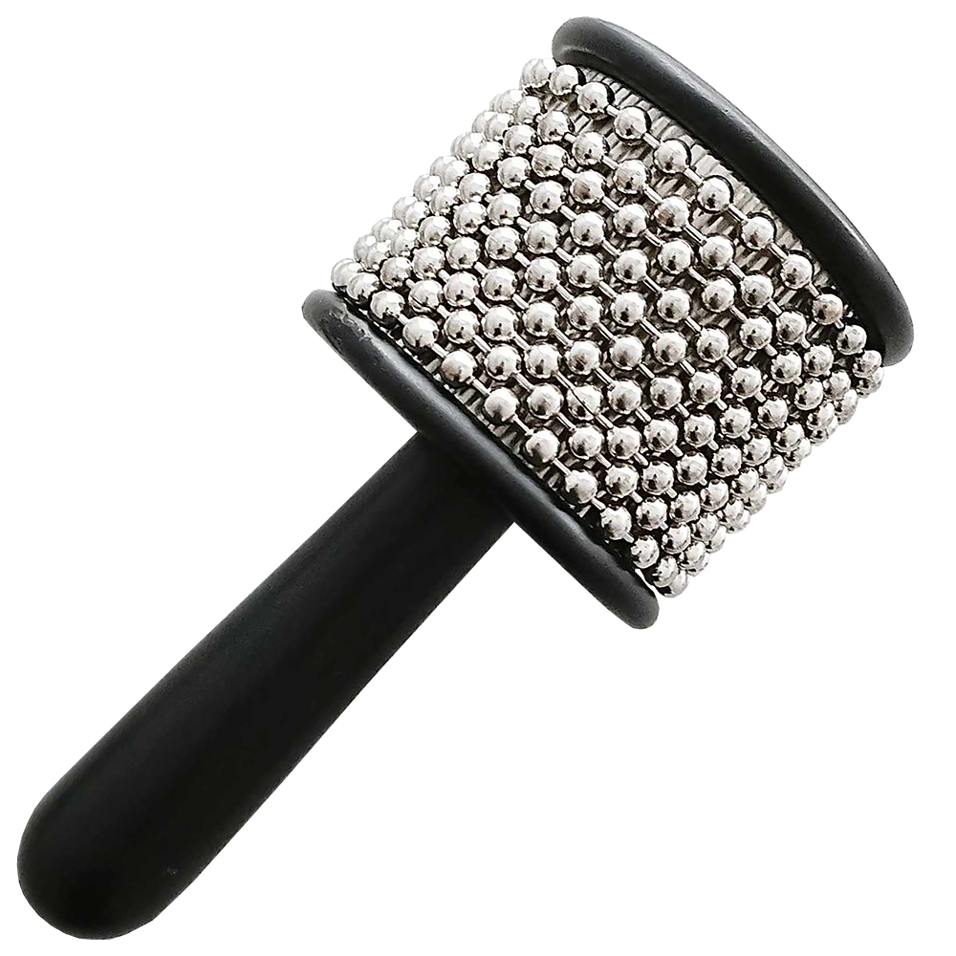Toca Percussion is happy to announce its new Cabasa/Shaker Combo, a hybrid instrument that seamlessly combines the rhythmic nuances of a traditional cabasa with the gentle, well-balanced tones of a steel shot-filled aluminum shaker.

The Toca Cabasa/Shaker introduces a distinctive design, featuring loops of steel bead chain wrapped around a specially textured, stainless steel cylinder. This unique construction produces a diverse array of scraping rhythmic patterns, offering percussionists a rich sonic tapestry that blends the characteristic texture of a cabasa with the soft, melodic sounds of the shaker.

When played, the Cabasa/Shaker generates an extensive range of rhythmic sounds and patterns, providing percussionists with a versatile palette for creative expression.

An indispensable addition to any percussionist's setup, the Cabasa/Shaker excels in both studio environments and live performances. Its versatility makes it the instrument of choice when soft shaker sounds are desired without sacrificing rhythmic complexity.

tocapercussion.com

rbimusic.com