**Contact:** Jim Rockwell **FOR IMMEDIATE RELEASE**

RBI Music

**Tel:** 201-247-7224

**Email:** jim.rockwell@rbimusic.com

**Toca Unleashes the Power of the Elements with Magma Freestyle Djembes**

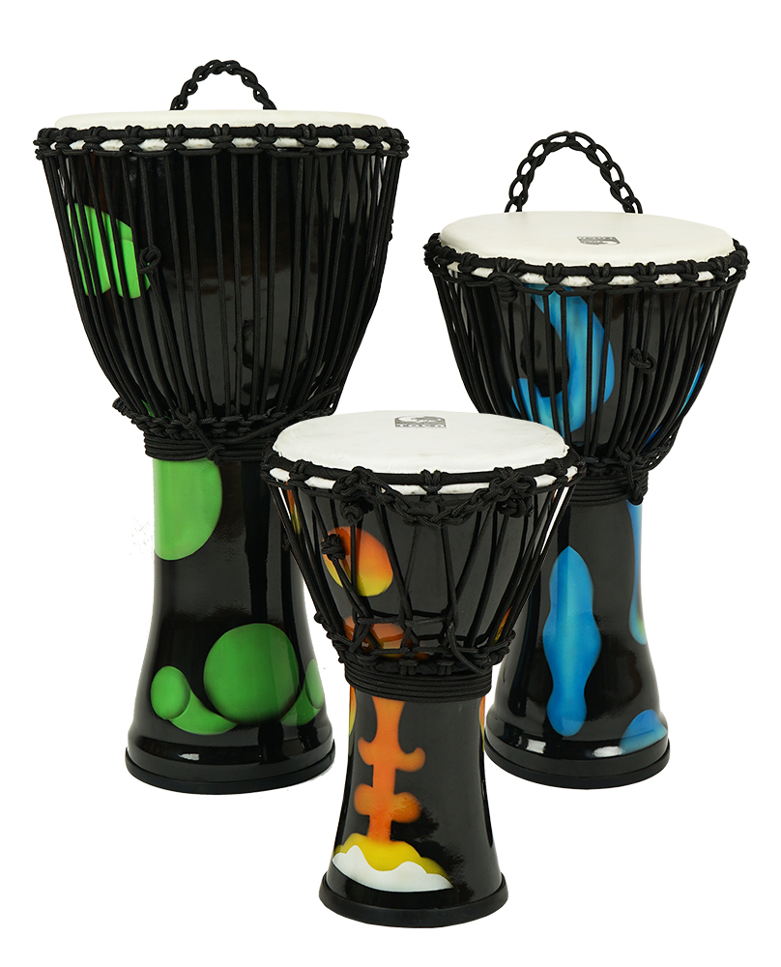Toca Percussion is proud to introduce the Magma Freestyle Djembes – a stunning addition to the Freestyle series that brings the elemental force of volcanic energy to your rhythm.

Crafted with precision and passion, the Magma Freestyle Djembes boast a range of features that set them apart in the world of percussion:

**Rope Tuned Excellence:** Each Magma Freestyle Djembe is meticulously tuned for optimal performance, providing drummers with a consistent and reliable sound for every beat.

**Hand-Selected Goatskin Head:** The djembes feature a hand-selected goatskin head, ensuring a rich and authentic sound that resonates with the spirit of traditional African drumming.

**Lightweight & Durable Seamless Synthetic Shell:** Built for the demands of both seasoned professionals and aspiring drummers, the Magma Freestyle Djembes feature a lightweight yet durable seamless synthetic shell, making them ideal for both stage and studio use.

**Versatile Size Options:** Available in 7", 10", and 12" head sizes, drummers can choose the perfect Magma Freestyle Djembe to suit their individual style and preference.

**Stability and Comfort:** Equipped with a rubber/non-slip bottom, these djembes stay securely in place, providing drummers with the stability needed for energetic performances.

**Innovative Alpine Rope Design:** The low stretch Alpine rope with braided cores not only ensures stable tuning but also contributes to the djembe's unique tonal qualities. This design produces a rich bass tone and sharp piercing rim tones, adding depth and character to every performance.

**Aesthetically Stunning "Magma" Shell Decoration:** The Magma Freestyle Djembes feature a visually striking "Magma" shell decoration that mimics the mesmerizing appearance of molten volcanic lava gracefully flowing down the side of an active volcano. This eye-catching design adds a touch of visual flair to the instrument, making a bold statement on any stage.

**Express Yourself with Magma Colors:** Available in three captivating molten lava colors – blue, orange, and green – the Magma Freestyle Djembes allow drummers to express their individuality with style.

Jim Rockwell, Product Manager at Toca Percussion, commented, "With the Magma Freestyle Djembes, we've created an instrument that not only sounds exceptional but also captivates the eyes. The combination of innovative features, quality craftsmanship, and expressive design makes the Magma Freestyle Djembes a must-have for drummers looking to elevate their performance."

tocapercussion.com

rbimusic.com