**Contact:** Jim Rockwell **FOR IMMEDIATE RELEASE**

RBI Music

**Tel:** 201-247-7224

**Email:** jim.rockwell@rbimusic.com

**Toca Strikes Again with the Kickboxx Pro – Drumming Innovation in a Portable Package**

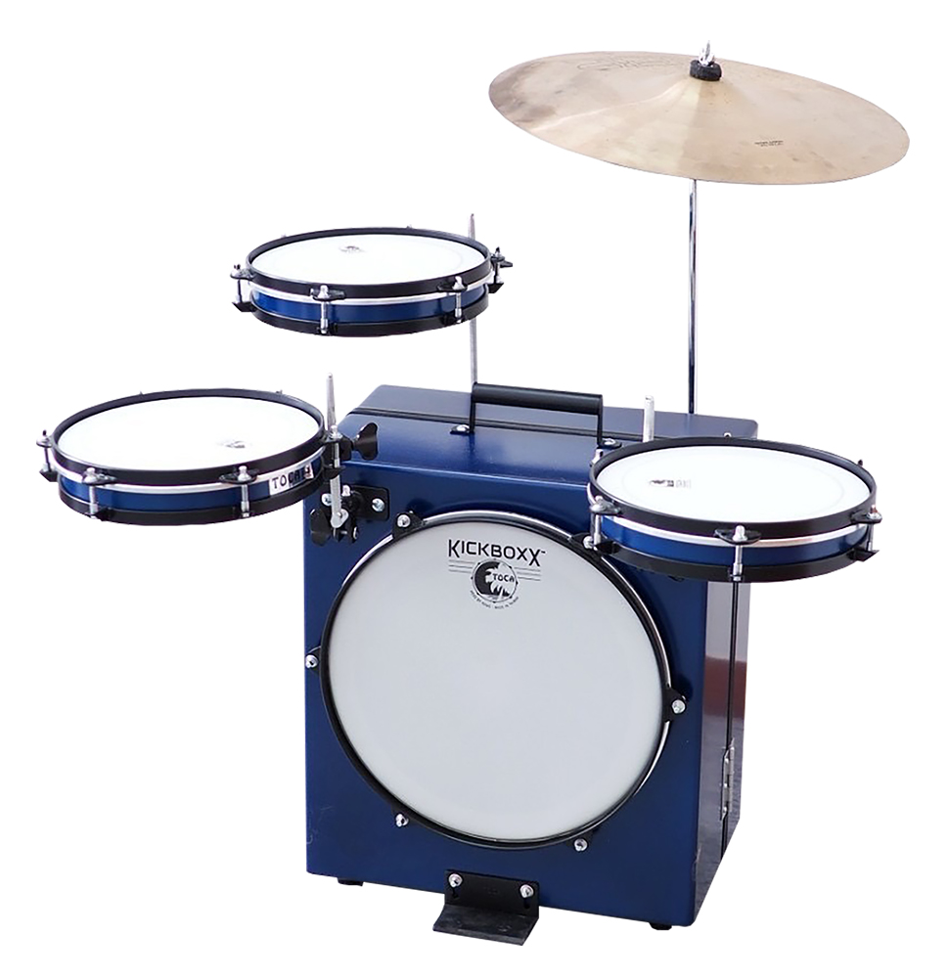Toca Percussion is proud to present the Kickboxx Pro, an evolution of the immensely popular Kickboxx Suitcase Drum Set. Combining portability with professional features, the Kickboxx Pro sets a new standard for compact drumming solutions.

The original Kickboxx has been a game-changer for drummers seeking portability without compromising on sound quality. Acting as a carrying case for the entire set, it has garnered widespread acclaim for its innovative design and practicality. Building upon this success, the Kickboxx Pro takes the concept to new heights, offering enhanced features for drummers of all levels.

The Kickboxx Pro, in a stunning Cobalt Blue shade, goes above and beyond its predecessor by doubling the amount of retractable accessory posts to four, allowing drummers to customize their setup even further. This enhancement not only provides more options for mounting accessories but also accommodates left-handed setups with ease.

The Kickboxx Pro also includes an extra 10” tom, transforming your setup into a full 4-piece drum kit. This addition opens up new possibilities for drummers to explore a wider range of rhythms and beats.

And the Kickboxx Pro introduces a cymbal attachment rod, giving drummers the flexibility to easily add their preferred crash or ride cymbal. This feature enhances the sonic capabilities of the drum set, making it suitable for a great number of musical styles.

"The Kickboxx Pro represents the next level in portable drumming solutions. We've taken the success of the orignal Kickboxx Suitcase Drum Set and elevated it with many more features, offering drummers unmatched customization. Whether you're a beginner or a seasoned pro, the KickBoxx Pro delivers the performance you need in a compact and convenient package," said Toca Product Manager, Jim Rockwell.

tocapercussion.com

rbimusic.com