**Contact:** Jim Rockwell **FOR IMMEDIATE RELEASE**

RBI Music

**Tel:** 201-247-7224

**Email:** jim.rockwell@rbimusic.com

**Toca Announces Grabber Percussion Mount for Microphones**

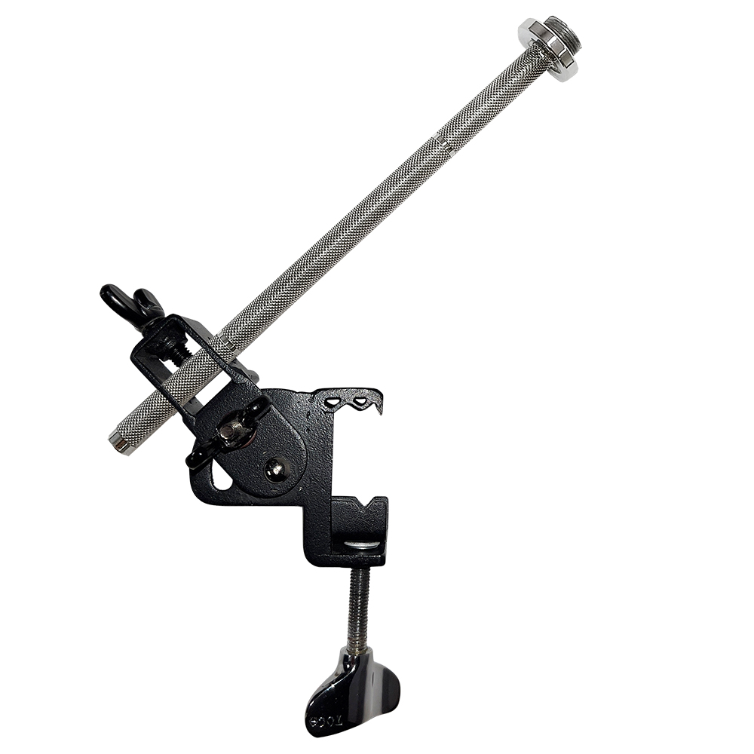Toca Percussion is building upon the success of The Grabber Percussion Mount with the introduction of the Toca Grabber Percussion Mount for Microphones. This mount offers drummers and percussionists a versatile solution to securely position microphones exactly where needed, enhancing the flexibility and customization of percussion rigs.

The original Grabber Percussion Mount simplified the way percussion accessories could be added to drum kits, providing a secure and adjustable solution for tight spaces. The Grabber for Microphones extends this functionality to microphones, offering drummers and percussionists the same level of adaptability and convenience.

Designed for drum kit setups and percussion rigs, the Grabber for Microphones features a standard percussion rod fitted with a threaded microphone connector. This allows users to choose their preferred microphone holder and easily attach it to the mount. The angle adjustability of the mount ensures precise positioning to meet the unique needs of each performance.

One of the standout features of the Toca Grabber for Microphones is its compatibility with nearly every standard drum rim. This versatility makes it an essential addition to any percussionist's toolkit, providing a secure and adjustable solution for holding microphones in various drumming setups.

For existing owners of the original Grabber Percussion Mount, Toca offers the option to purchase the threaded rod separately, allowing them to adapt their current Grabber for microphone use.

tocapercussion.com

rbimusic.com