**Contact:** Jim Rockwell **FOR IMMEDIATE RELEASE**

RBI Music

**Tel:** 201-247-7224

**Email:** jim.rockwell@rbimusic.com

**Toca Jamal Gome Drum – A Fusion of Tradition and Innovation**

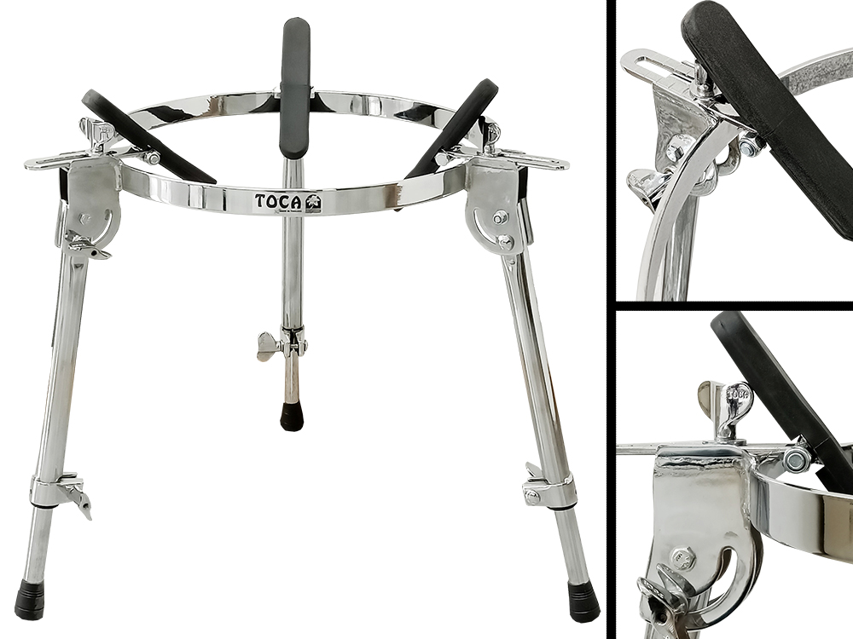Toca Percussion, a pioneer in the world of percussion instruments, proudly introduces the Toca Jamal Gome Drum. Developed in partnership with world-renowned percussionist and educator Jamal Mohamed, this instrument promises a unique and versatile percussion experience.

The Gome drum, a cultural cornerstone in the solo and ensemble traditions of the Ga and Ashanti communities, has found a contemporary expression in the Toca Jamal Gome Drum. This distinctive drum delivers soul-stirring rhythms.

Jamal shared his insights into the creation of this innovative instrument: "The Toca Jamal Gome Drum is a fusion of tradition and innovation. Working closely with Toca Percussion, we took the essential elements of the traditional Gome drum and seamlessly merged them with the familiar cajon, resulting in an instrument that not only respects its roots but also offers a new avenue for creative expression."

Key Features of the Toca Jamal Gome Drum:

**1. Innovative Design:** Featuring a skin head reminiscent of traditional Gome models and a cajon-like body, the Toca Jamal Gome Drum is a visual and sonic masterpiece that captures the essence of both worlds.

**2. Sonic Excellence:** With the ability to produce thick warm tones, striking slaps, and resonant bass, the Toca Jamal Gome Drum promises a diverse and captivating sonic experience.

**3. Proprietary Tuning System:** The Toca Gome Drum introduces a game-changing, patented, on the fly tuning system. By simply turning the handle, drummers can unlock a wide range of sounds not typically achievable, all completed in mere seconds.

**4. Replaceable Head Feature:** Setting itself apart from conventional cajons, the Toca Jamal Gome Drum offers a replaceable head, providing percussionists with an additional level of flexibility. Swapping out the head can be accomplished in just a few minutes, ensuring longevity and versatility.

tocapercussion.com

rbimusic.com