**Contact:** Jim Rockwell **FOR IMMEDIATE RELEASE**

RBI Music

**Tel:** 201-247-7224

**Email:** jim.rockwell@rbimusic.com

**Toca’s New Collapsible Barrel Stand Proves that the Little Things Really Do Count**

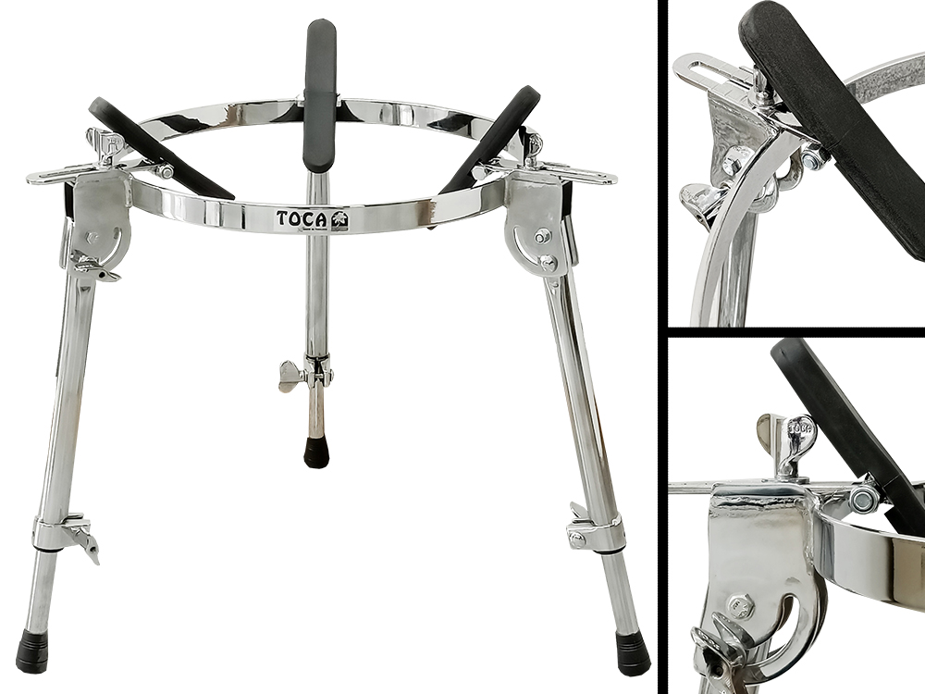Toca Percussion a leading innovator in percussion accessories, proudly announces their brand new Fully Collapsible Conga Barrel Stand. This groundbreaking stand represents a leap forward in convenience, versatility, and design for percussionists.

In the world of percussion, it's often the subtle details that set exceptional equipment apart. This new barrel stand is a testament to this philosophy, featuring fully height-adjustable legs and rubber grippers that elevate the playing experience to new heights.

One of the standout features of this innovative stand is its fully foldable legs, a vast improvement over the previous model that only partially folded down. This enhancement allows for compact storage in gig bags or road cases, making it an ideal companion for the musician on the go.

Weighing less than its predecessor, the new design doesn't compromise on sturdiness. Crafted from heavy-gauge, chrome-plated steel, the stand ensures durability while maintaining a lightweight profile. The sturdy tripod design guarantees stability, providing percussionists with a reliable foundation for their instruments.

Setting up and breaking down your percussion setup has never been easier. This stand boasts amazingly quick assembly times, thanks to simplified mechanics. What truly sets it apart is the drum size demarcation adjustment lines for quick and precise set up. These lines make it a breeze to position the rubber grippers, securing your conga in place effortlessly. With this feature, you'll always know exactly where to set the drum grips for any size conga, streamlining your setup process.

Toca Product Manager, Jim Rockwell, expressed his enthusiasm about the new barrel stand, stating, "We've listened to the needs of percussionists and drummers worldwide, and we've delivered a solution that not only meets but exceeds their expectations. The attention to detail reflects our commitment to providing musicians with tools that enhance their craft."

The Toca Fully Collapsible Conga Barrel Stand is designed to accommodate nearly every model of conga, making it a versatile choice for percussionists across genres.

tocapercussion.com

rbimusic.com