**Contact:** Jim Rockwell **FOR IMMEDIATE RELEASE**

RBI Music

**Tel:** 201-247-7224

**Email:** marketing@rbimusic.com

**Toca Unveils Exquisite Eric Piza Signature Congas and Bongos**

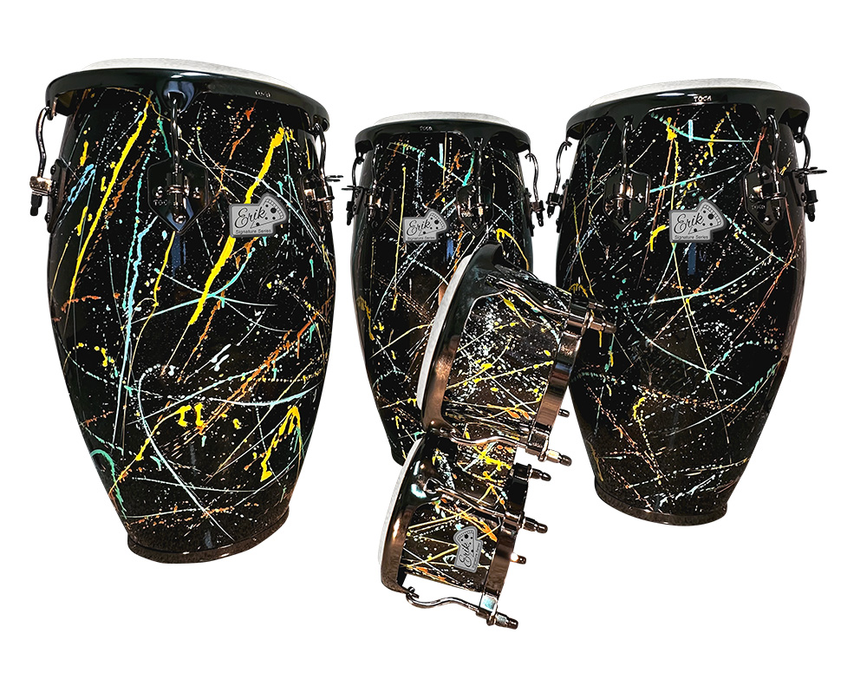Toca Percussion, a leading name in the world of percussion instruments, proudly introduces the striking new EP Splash Congas and Bongos. This collaboration between Toca and renowned percussionist Erik Piza brings a burst of artistic flair to the world of percussion, offering a unique visual and auditory experience for drum enthusiasts.

The EP Splash drums feature a gloss black base coat adorned with vibrant splashes of yellow, teal, and Erik's signature orange. The artistic expression of these drums draws inspiration from the works of Jackson Pollock, creating a dynamic and visually stunning design that captivates both the eyes and ears.

What sets these drums apart is not just their visual appeal but also the craftsmanship involved in their creation. Each drum is meticulously hand-painted, making every single piece a distinctive work of art. Erik Piza, percussionist for Bernie Williams, expresses his excitement, saying, "I'm so thrilled to have such amazing-looking drums with my name on them. They have exceeded my expectations."

Toca Product Manager, Jim Rockwell, echoes the sentiment, emphasizing the collaborative process that brought these drums to life. "Working with Erik on these drums was a fantastic experience. Not only do they bring a unique design to the market, but each drum is truly a one-of-a-kind creation."

The EP Splash Design Congas and Bongos not only serve as instruments for musical expression but also stand as pieces of visual art that elevate the aesthetics of any performance or collection. The combination of the glossy black base and the bold splashes of color creates a stunning contrast, ensuring that these drums make a statement both on and off the stage.

For drummers and collectors seeking instruments that go beyond the ordinary, the Eric Piza Splash Design Congas and Bongos by Toca Percussion are a testament to innovation and artistic collaboration.

tocapercussion.com

rbimusic.com