**Contact:** Jim Rockwell **FOR IMMEDIATE RELEASE**

RBI Music

**Tel:** 201-247-7224

**Email:** jim.rockwell@rbimusic.com

**Toca Accelerates Style with Custom Deluxe Matte Finish Congas and Bongos**

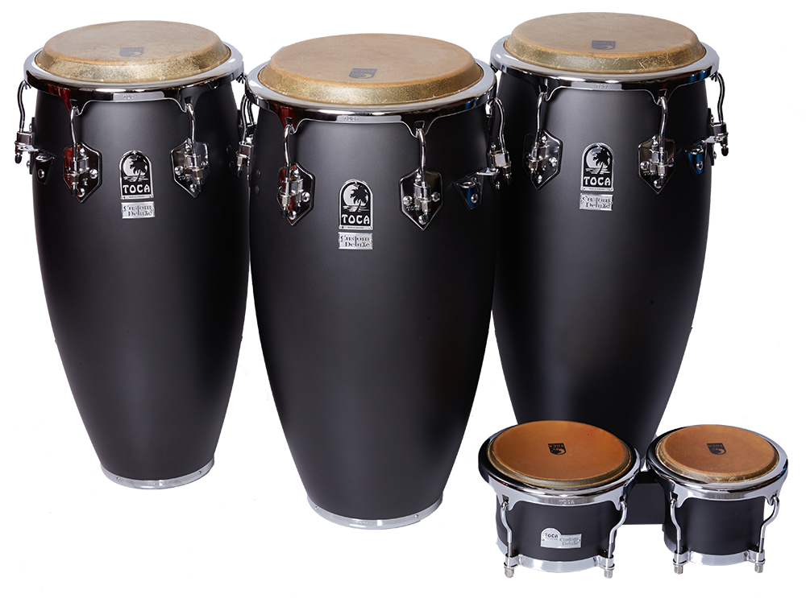Toca Percussion introduces the new Custom Deluxe Matte Finish Congas and Bongos. These instruments, available in striking Matte Gray and Matte Blue, redefine traditional hand percussion aesthetics with a touch of sophistication and modernity.

In a landscape where hand percussion often embraces conventional colors, Toca Percussion once again breaks the mold. The Custom Deluxe Matte finish congas and bongos draw inspiration from the sleek aesthetics of sports cars and rugged pickup trucks, offering a breath of fresh air in the world of hand percussion design.

The congas, with their 30" tall Asian Oak shells and Afro-Cuban shell shape, deliver enhanced volume and resonance, ensuring a powerful and rich sound that captivates audiences. Durable chrome hardware provides elegance and longevity, while the EasyPlay hoop design and 6 lugs contribute to playability and tuning stability.

Equipped with matched, top-grade natural bison heads, the Custom Deluxe congas produce warm and authentic tones that resonate with hand percussion traditions. The matching bongos complete the ensemble, offering drummers a visually cohesive and sonically dynamic setup.

Jim Rockwell, Product Manager at Toca, spoke of the new additions to the line, "In the world of hand percussion, Toca has always been a trailblazer when it comes to design. These new Custom Deluxe congas and bongos embody the spirit of speed and style, offering drummers not just instruments but expressions of their individuality. Stand back and watch them fly by!"

tocapercussion.com

rbimusic.com