**Contact:** Jim Rockwell **FOR IMMEDIATE RELEASE**

**RBI Music**

**Tel:** 201-247-7224

**Email:** jim.rockwell@rbimusic.com

**Introducing Grover Protégé Woodblocks: Precision Crafted for Professional Sound**

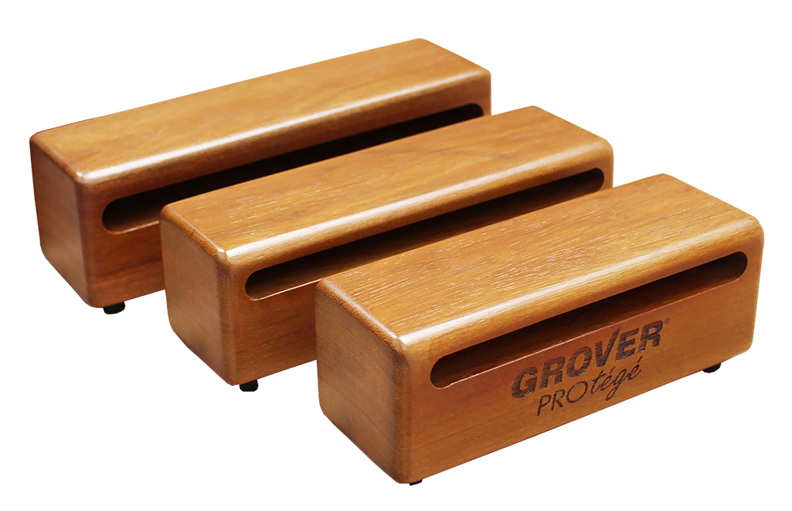Grover Pro, renowned for its commitment to crafting top-tier percussion instruments, proudly presents the Protégé series Woodblocks, a stellar addition to their esteemed lineup. Meticulously hand-crafted from the finest exotic hardwoods, these woodblocks are engineered to deliver a well-defined, focused sonority that meets the discerning standards of musicians worldwide.

Available in three popular sizes – 7", 8", and 9" – Grover Protégé Woodblocks offer versatility and superior performance in a variety of musical settings. Whether you're a music educator, student, or seasoned professional, these woodblocks are designed to meet the demands of all performance situations.

Created with the needs of music educators, students, and professionals in mind, Grover Protégé Woodblocks strike the perfect balance between exceptional sound and outstanding value. These woodblocks are a testament to Grover Pro's dedication to providing a true "sound-value" – where uncompromising quality meets affordability.

"Our Protégé Woodblocks exemplify our commitment to delivering high-quality percussion instruments that resonate with musicians of all levels. We've taken great care in hand-crafting these woodblocks using the finest exotic hardwoods to ensure a professional sound that exceeds expectations," says Grover Pro founder, Neil Grover.

Discover the unparalleled sound experience of Grover Pro's Protégé Woodblocks – where craftsmanship, quality, and value converge to elevate your musical performance.

groverpro.com

rbimusic.com