**Contact:** Jim Rockwell **FOR IMMEDIATE RELEASE**

**RBI Music**

**Tel:** 201-247-7224

**Email:** jim.rockwell@rbimusic.com

**Grover Protégé Tambourines: Exceptional Sound, Unmatched Value**

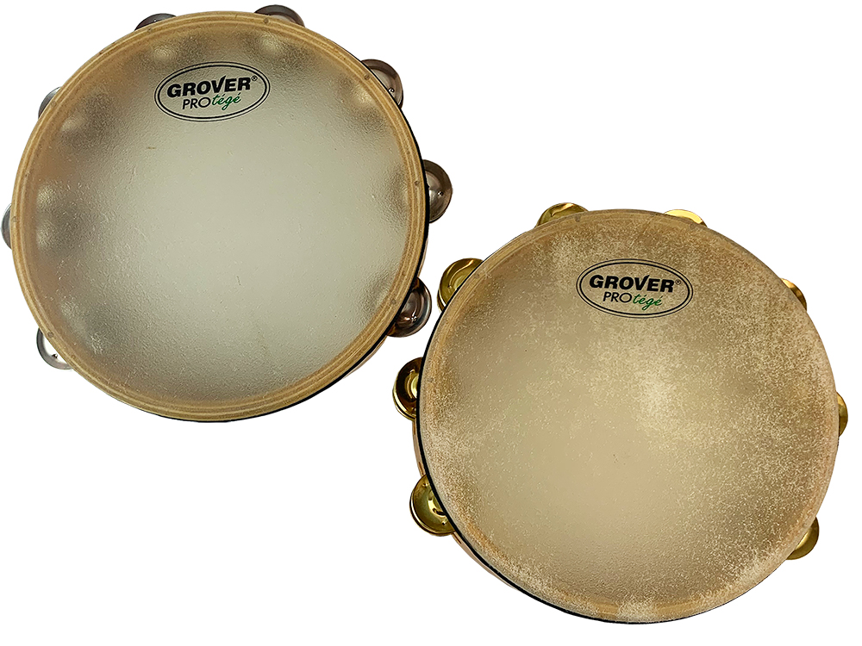Grover Pro has announced the Protégé model tambourines—designed to deliver unparalleled sound quality and exceptional value for budget-minded students and music educators. The Protégé tambourines seamlessly incorporate professional features for a superior playing experience, setting a new standard in the world of student level concert tambourines.

Grover Protégé tambourines have been meticulously developed to offer an unmatched "bang for the buck" compared to any other concert tambourine. These instruments provide an ideal solution for general-purpose band and orchestral playing, catering to the needs of both aspiring musicians and seasoned educators.

These tambourines boast a hardwood shell with a resilient high gloss finish, ensuring longevity and a polished appearance. The exclusive finger grip design caters to smaller hands, enhancing comfort and control during performances. They also feature captive jingle pins, providing peace of mind as they will never fall out during play. Additionally, each tambourine is equipped with a professional-grade head, contributing to a superior and consistent sound quality. And as an added bonus, every Protégé tambourine comes with a complimentary protective bag, offering convenience and safeguarding the instrument during transportation.

Musicians have the option to select from two professional-grade jingle alloys, each offering a distinct sonic profile: German Silver Jingles that produce a bright and articulate sonority. Or Brass Jingles that generate a full midrange sound.

Grover Pro Founder, Neil Grover stated, "Dollar for dollar, our Protégé tambourines deliver exceptional value in sound, setting a new standard for quality and affordability. These instruments are a testament to our dedication to providing accessible yet professional-grade percussion options."

groverpro.com

rbimusic.com