**Contact:** Jim Rockwell **FOR IMMEDIATE RELEASE**

RBI Music

**Tel:** 201-247-7224

**Email:** marketing@rbimusic.com

**Toca Multi-Use Bongo Stand Combines Two Stands Into One**

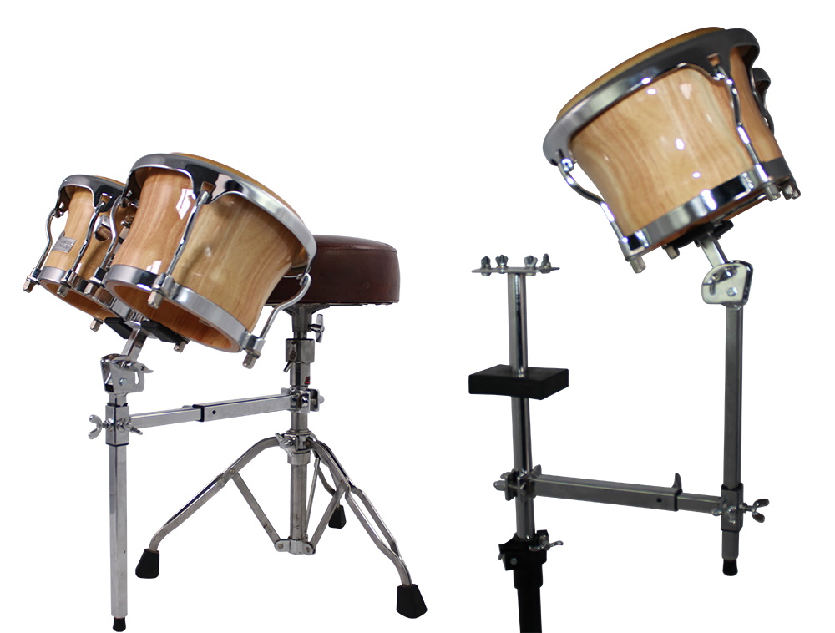Toca Percussion is eccited to introduce the Toca Multi-Use Bongo Stand, a versatile and durable stand that combines the functionality of seated bongo stands and bongo arms into one product.

The Toca Multi-Use Bongo Stand allows musicians to play the bongos while seated on a throne or attach them to a double conga stand. With its C-Clamp bongo mount and adjustable height and angle, this stand is fully customizable to meet any playing style.

Designed to fit any double conga stand, this sturdy and durable stand is built to last. It adds extra bongos to your set, without taking up floor space, making it an ideal add-on for any drummer or percussionist.

“We are excited to introduce the Toca Multi-Use Bongo Stand to our customers,” said a spokesperson for Toca Percussion. “Our team has worked hard to create a versatile and durable product that can be used by drummers and percussionists of all skill levels. With its fully adjustable design, the Toca Multi-Use Bongo Stand is sure to become an essential part of any percussionist's set up.”

tocapercussion.com

rbimusic.com