**Contact:** Jim Rockwell **FOR IMMEDIATE RELEASE**

RBI Music

**Tel:** 201-247-7224

**Email:** marketing@rbimusic.com

**Toca Percussion Introduces Two New Drum Set Timbales with Snares for Enhanced Sound Palette**

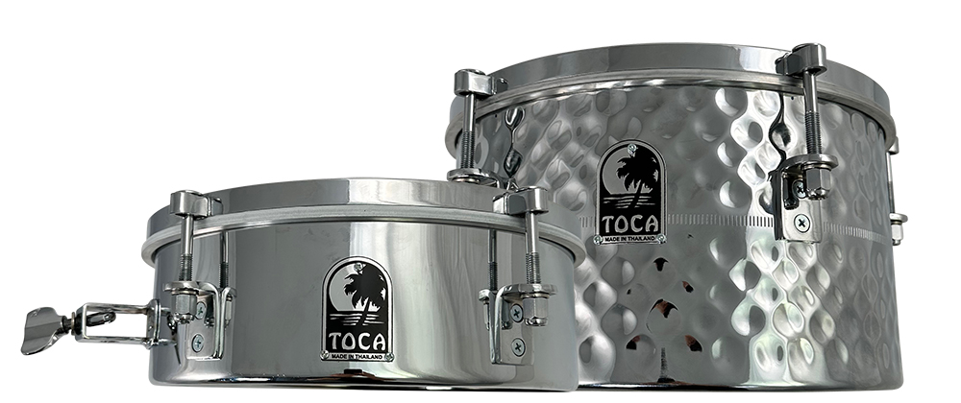

Toca Percussion, the world-renowned percussion instrument brand, is thrilled to announce the release of two new drum set timbales, equipped with snares. These innovative new instruments provide drummers with an expanded range of sound options, and are perfect for drummers looking to add new elements to their music.

The first of these two new timbales is the 12” x 4” version, which features a stunning stainless steel finish. The smaller head size of this timbale makes it easy to place in tighter spaces, while the steel shells provide maximum sustain, brightness, and clarity. What's more, this timbale comes equipped with a snare, enabling drummers to easily transition from a unique timbale sound to a snappy snare sound.

The second of Toca's new drum set timbales is the 12” x 7” model, which boasts all the same features as its smaller counterpart, but with a deeper ring and a stunning hand-hammered stainless-steel finish that is sure to dazzle audiences. Both these drum set timbales come with a heavy-duty mount that accommodates a variety of rods and tom holders, making them easy to place on any drum set.

"These Drum Set Timbales fill a sweet spot for drummers looking for a timbale sound, and a little bit more,” said Jim Rockwell, Marketing & Product Manager for Toca Percussion. "The size is just right, they are easy to place on a mount or stand, they sound amazing, and you have the added benefit of a snare throw off. We are really excited to augment the sound palette of drummers everywhere, and can’t wait to see how they use these timbales on their kits.”

Toca Percussion has a reputation for providing top-quality percussion instruments, and these two new drum set timbales with snares are no exception. With these new instruments, drummers can easily add new elements to their music, enhancing their overall sound palette and taking their performances to the next level.

tocapercussion.com

rbimusic.com