**Contact:** Jim Rockwell **FOR IMMEDIATE RELEASE**

**RBI Music**

**Tel:** 201-247-7224

**Email:** marketing@rbimusic.com

**Grover Pro Releases New Rosewood Castanets**

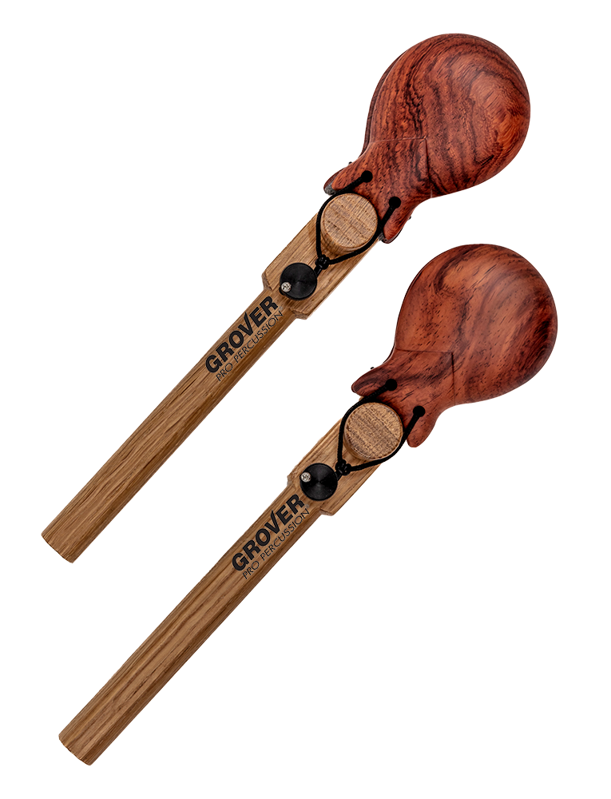Grover Pro Percussion is excited to announce the release of its new Rosewood Castanets. If you're frustrated by having to choose between castanets that sound good but have no adjustment and others which have adjustable tension but lack clarity and richness of sound, then these castanets are for you! Once you try them, you'll fall in love with the sound and super responsive tension adjustment.

The Grover Rosewood Castanets feature solid rosewood clappers and a simple belt-tension adjustment that can be set to micro-fine settings and remain consistent while using. The comfortable lightweight oak handle ensures that these castanets are easy to hold and play for extended periods of time. In addition, the GWC-2R castanets come with free protective covers, making them easy to store and transport safely.

These castanets are slightly smaller and brighter sounding than their large granadillo model, providing a unique sound and tone that will sets it apart. These castanets are perfect for musicians who demand the best in terms of sound quality and performance capabilities. Like all Grover Pro Percussion instruments, the Rosewood Castanets come with a limited lifetime guarantee, ensuring that customers can trust the quality and durability of their purchase.

If you're ready to experience the ultimate castanet sound and tension adjustment, then the Grover Pro Percussion Rosewood Castanets are the perfect choice for you. Get yours today and start playing with confidence!

groverpro.com

rbimusic.com