**Contact:** Jim Rockwell **FOR IMMEDIATE RELEASE**

**RBI Music**

**Tel:** 201-247-7224

**Email:** marketing@rbimusic.com

**Grover Pro Introduces Dual Action Castanet Machine**

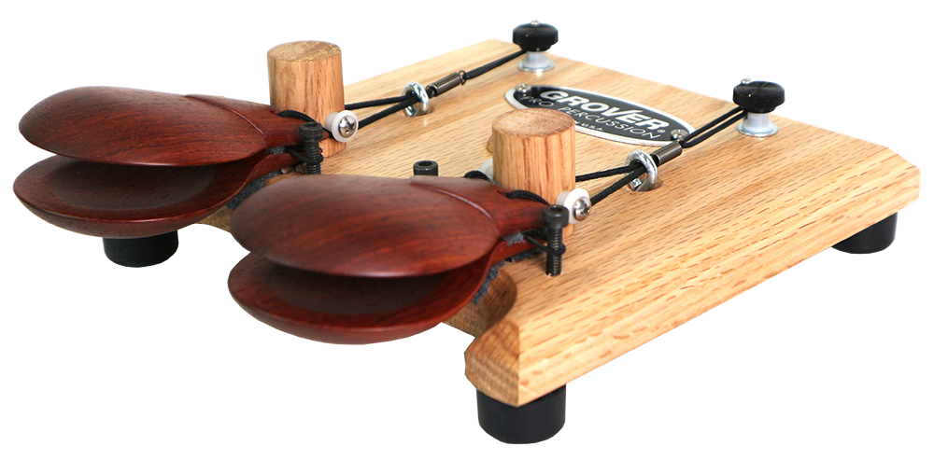Grover Pro Percussion is proud to introduce its latest innovation – the Grover Pro Dual Action Castanet Machine. This new product is the only castanet machine in the market that offers two settings to optimize dynamic range response. When properly adjusted, the Grover Pro Dual Action Castanet Machine enables musicians to sound their absolute best!

This model of castanets are slightly smaller and brighter sounding than their large granadillo model, and feature medium-sized clappers made of solid Rosewood. The tension of the castanets is fully adjustable, thanks to the simple tension adjustment knob that can be set to micro fine settings, remaining consistent throughout use.

In addition, the Grover Pro Dual Action Castanet Machine boasts a compact footprint, which makes it ideal for tabletop or cymbal stand mounting. It is designed to offer superior sound quality and performance for musicians of all levels. This product is backed by Grover Pro's limited lifetime guarantee, ensuring that customers can trust the quality and durability of their purchase.

The Grover Pro Dual Action Castanet Machine has already received rave reviews from customers, including Professor David Eyler from Concordia College. "We absolutely love our new Grover Pro Dual Action Castanet Machine!" said Eyler. "The fully adjustable tension and tabletop or cymbal stand mounting design make it so easy to use. Thank you Grover Pro for another outstanding product in your arsenal!"

Musicians of all levels looking for exceptional castanet sound quality and performance should check out this incredible new product.

groverpro.com

rbimusic.com