**Press Release**  
**Embargoed until 12 April 2023**

Please do not publish prior to this time.  
United Kingdom. February 2023.





**Fret-King Eclat Custom Paul Rose Signature guitar launched.**

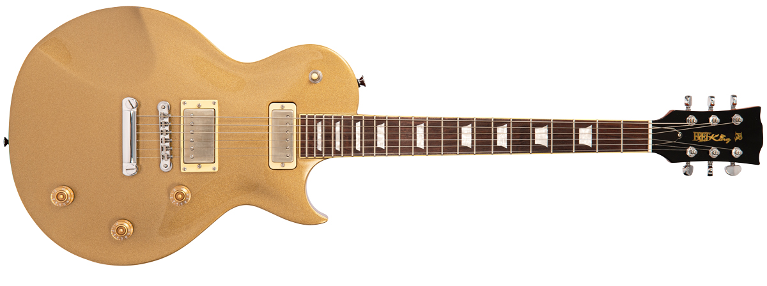Fret-King® has partnered with Paul Rose, one of the world’s most unique and widely respected guitarists, to create the Eclat™ Custom Paul Rose Signature electric guitar, for the new 2023 Collection of Fret-King electric guitars and basses.

With a gorgeous Gold Top finish, this stunning single cutaway guitar is crafted from the finest materials and assembled with scrupulous attention to detail by skilled luthiers.

Features include a solid carved maple cap with the Eclat’s flagship ‘Forearm Scoop’, two-piece centre-joined, bound mahogany body, mahogany neck and bound 22 fret premium Indian rosewood fingerboard with inlaid crown position markers, whilst an easy ride to the upper frets is assured by way of the subtle heel chamfer.

A brand new series of Fret-King pickups specifically created by Trev Wilkinson for the Fret-King 2023 collection includes the Focusfield™ Alnico V mini double coil pickup in the neck position and the Fifty-Five™ wax-potted Alnico V double coil at the bridge.

For maximum performance versatility and the broadest tonal palette, this beautiful guitar includes a master volume with latching ‘Kill Switch’, latching out-of-phase sonics between pickups, and Fret-King’s ingenious Varicoil™ system, which progressively rolls the Fifty-Five and Focusfield pickups from double coil to single coil, separately or together.

“I have several nice guitars that I would say are 8/10”, says Paul Rose, “But this guitar is as good as it gets, it’s a 10 all the way.”

FKV1CPRGT Fret-King Eclat Custom Paul Rose Signature £899.00 rrp.

//ENDS//

**Visit Fret-King guitars in Hall C Booth 7415 at The NAMM Show 2023.**

Fret-king guitars are distributed worldwide exclusively by JHS and distributed in the USA by RBi

Website here: <https://vintageguitarsrus.com> or in the USA here: <www.VintageGuitarsus.com>  
  
Please email Lars Mullen [larsm@jhs.co.uk](mailto:larsm@jhs.co.uk) to arrange for review samples.  
  
To discuss Vintage in the United States, speak to Rick Taylor at 817-335-2561 ext.105, or email [rick.taylor@rbimusic.com](mailto:rick.taylor@rbimusic.com)

Images available to download here: [Fret-King](https://1drv.ms/u/s!AoWp5wJmDu0HhpJTCd18nlefgc7k8A?e=KOe2XX)